Final project

Project Structure

devops-build/
├── build/ # React production build output (static files)
│ ├── static/
│ ├── _redirects
│ ├── asset-manifest.json
│ ├── favicon.ico
│ ├── index.html
│ ├── logo192.png
│ ├── logo512.png
│ ├── manifest.json
│ └── robots.txt
├── Dockerfile # Dockerfile to serve build with nginx
├── docker-compose.yml # Docker Compose file for deployment
├── build.sh # Bash script to build docker image
├── deploy.sh # Bash script to deploy/run container
├── .dockerignore # Docker ignore file
├── .gitignore # Git ignore file
├── Jenkinsfile # Jenkins pipeline script for CI/CD
├── README.md # Project documentation

1.Clone and Review Application

# Step 1: Clone the repo (correcting URL)

Change my local directory

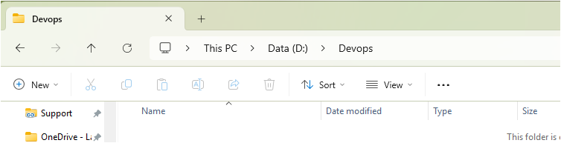
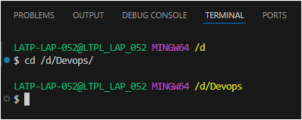

git clone https://github.com/sriram-R-krishnan/devops-build
cd devops-build
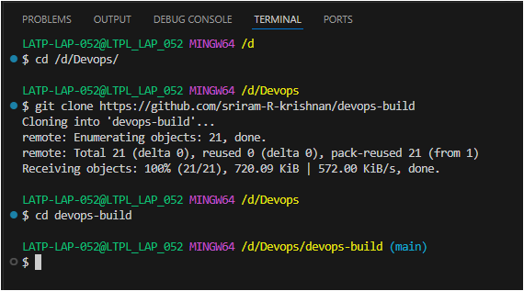

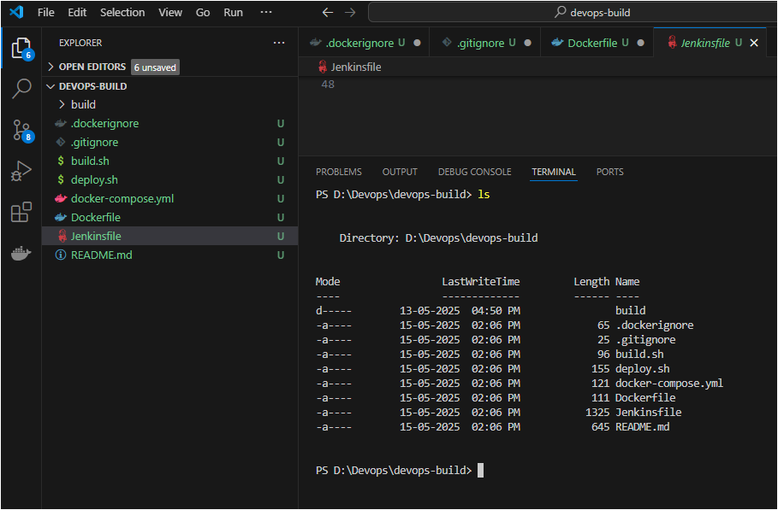

# Initialize git and add remote
git init
git remote add origin https://github.com/ajithdevopsproject/devopsfinalproject.git

# Add files
git add .
git commit -m "Initial commit with Docker, scripts, and Jenkins setup"

# Push to dev branch
git branch -M dev
git push origin dev

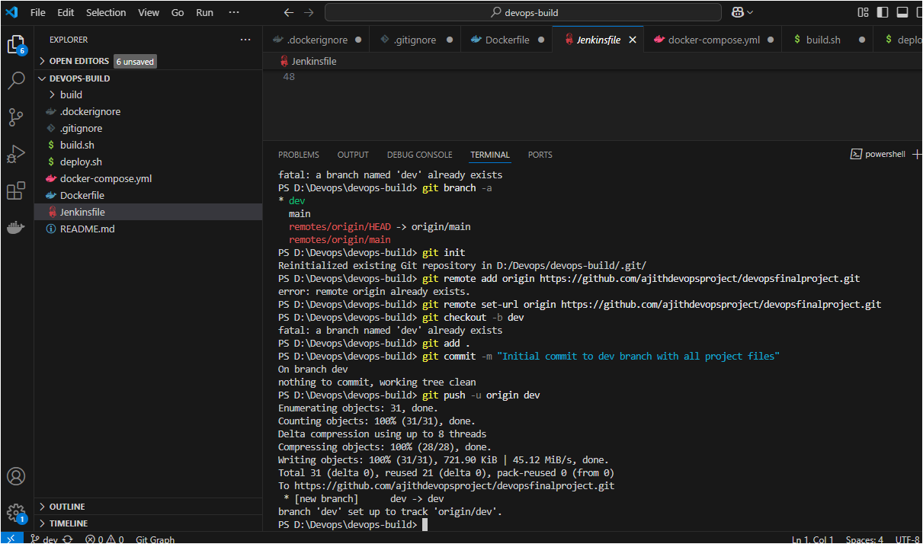
https://github.com/ajithdevopsproject/devopsfinalproject/tree/dev

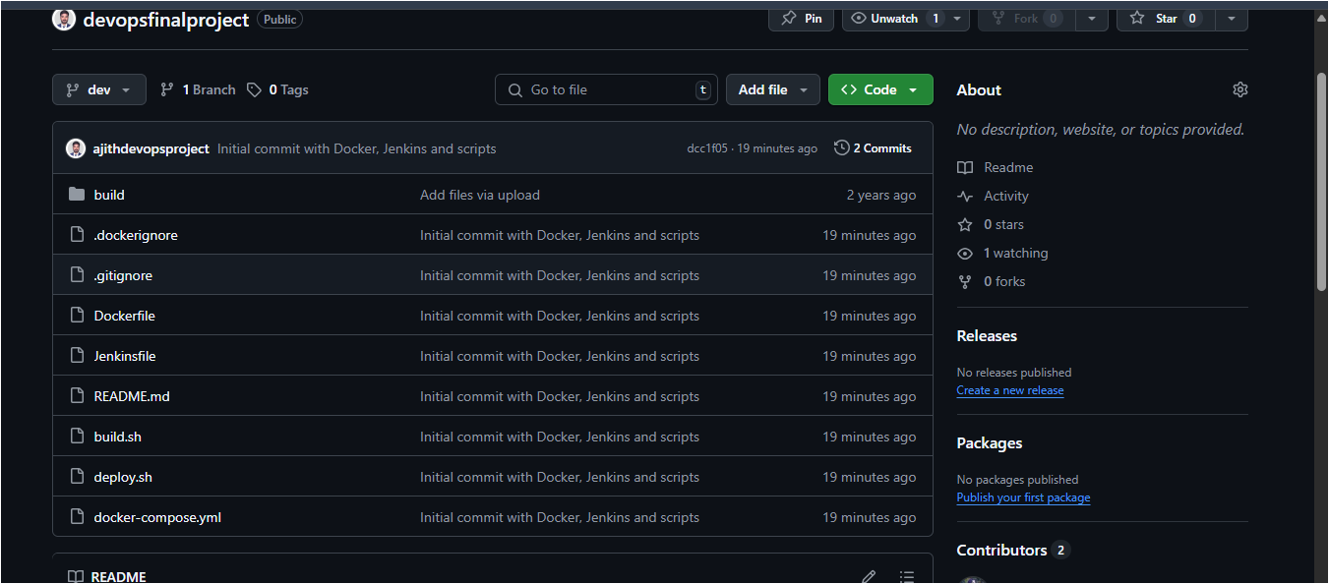

Crate docker prod and dev

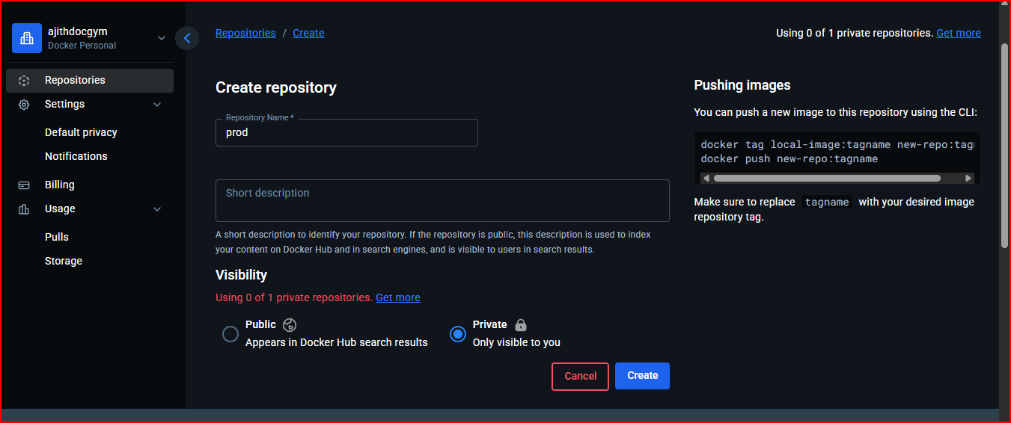
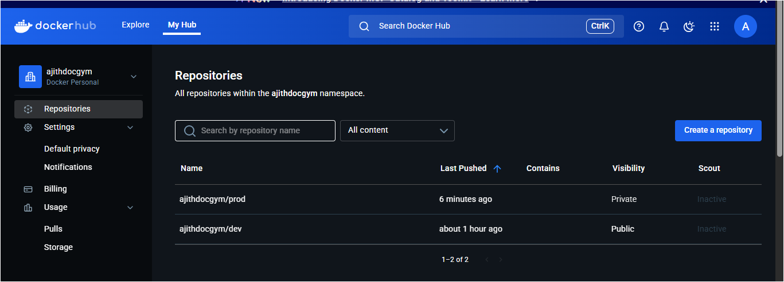

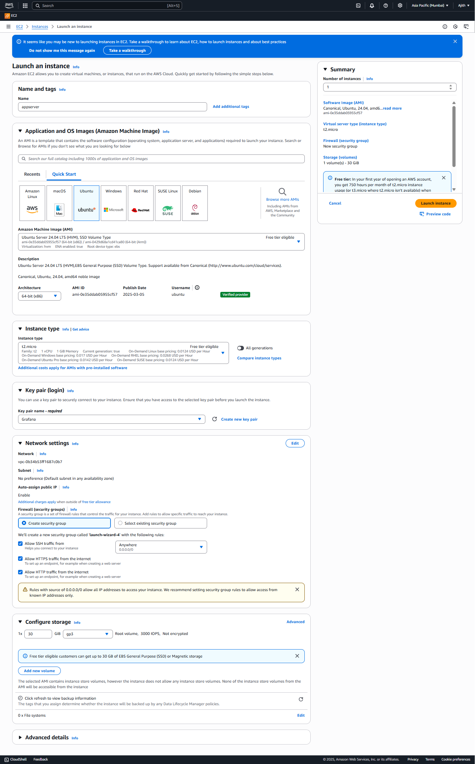

Jenkins CI/CD Automation for Docker-Based App
sudo apt update
sudo apt install openjdk-17-jdk -y
curl -fsSL https://pkg.jenkins.io/debian-stable/jenkins.io-2023.key | sudo tee \
/usr/share/keyrings/jenkins-keyring.asc > /dev/null
echo deb [signed-by=/usr/share/keyrings/jenkins-keyring.asc] \
https://pkg.jenkins.io/debian-stable binary/ | sudo tee \
/etc/apt/sources.list.d/jenkins.list > /dev/null
sudo apt update
sudo apt install jenkins -y
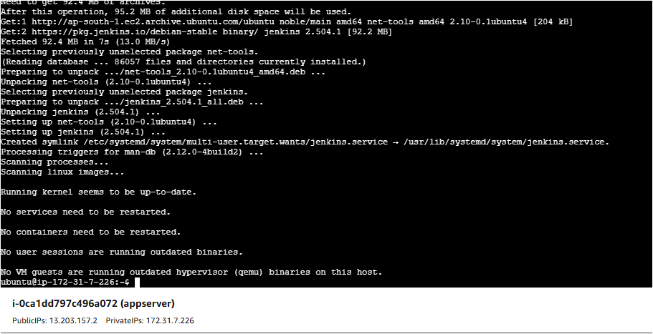
Start Jenkins:
sudo systemctl enable jenkins
sudo systemctl start jenkins
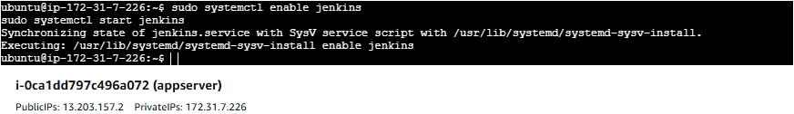

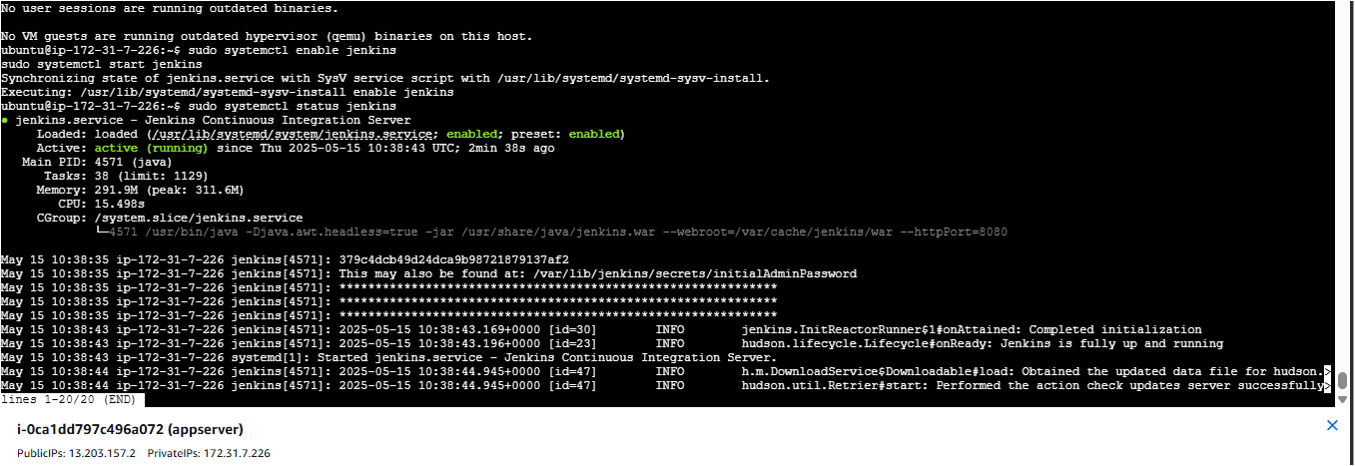
Need to enable 8080 Port
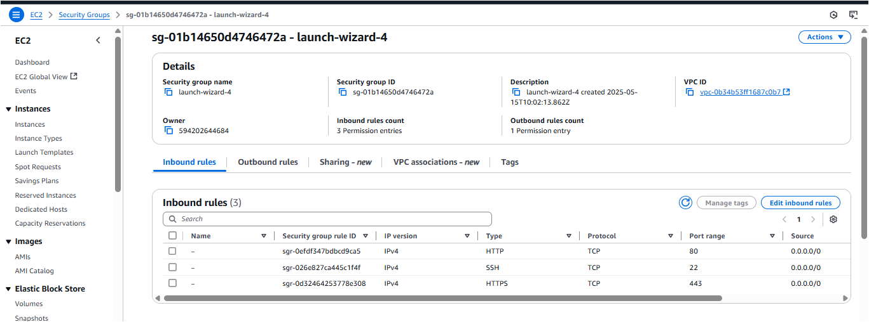
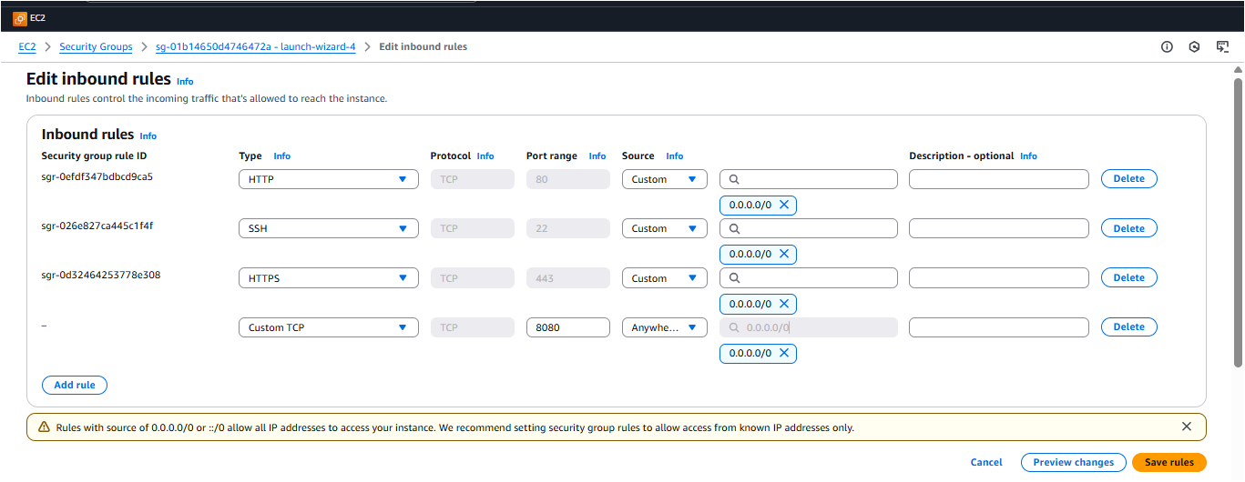

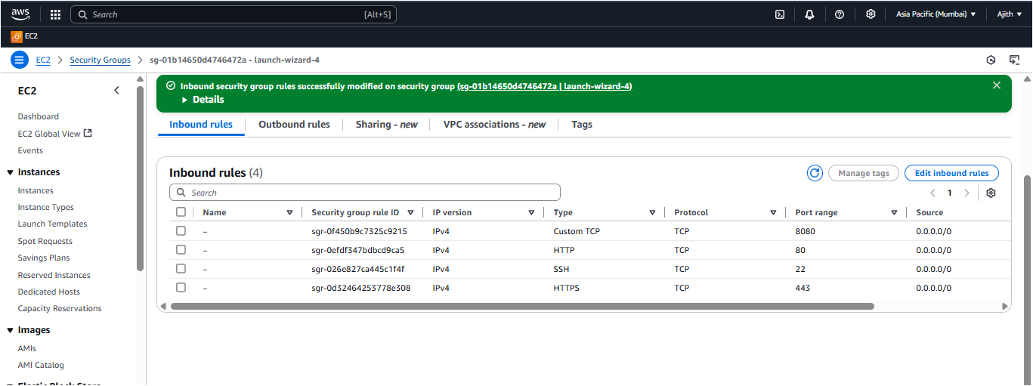
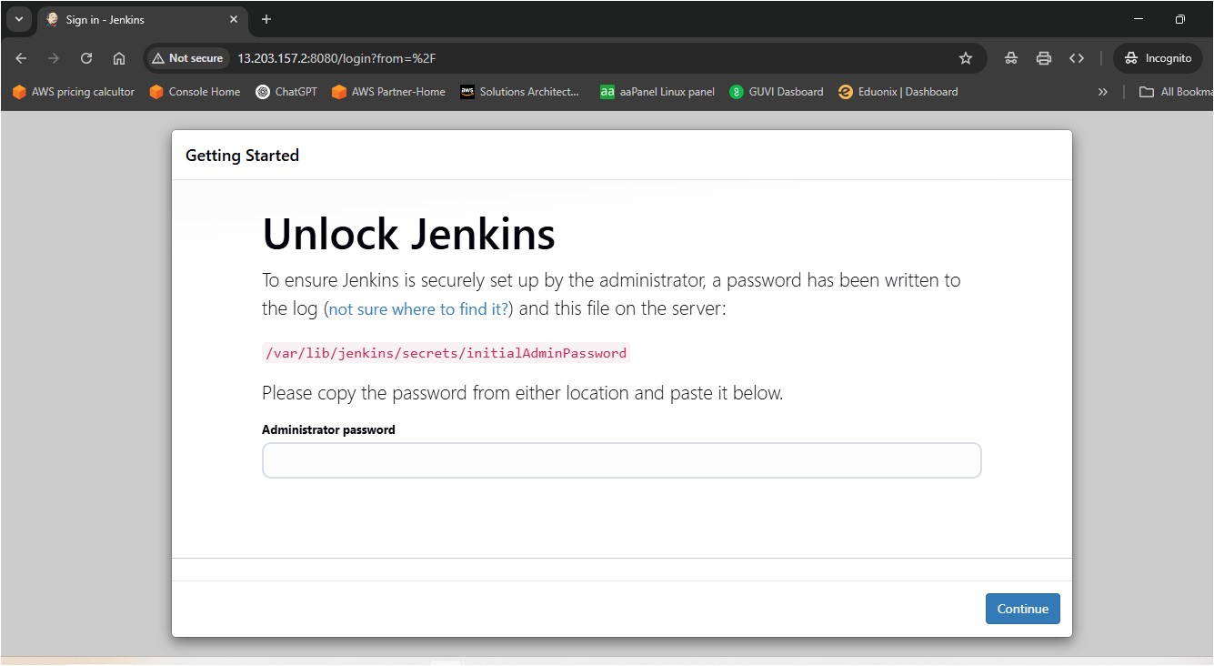
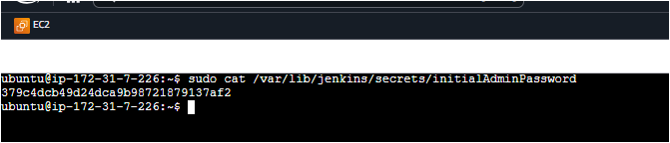
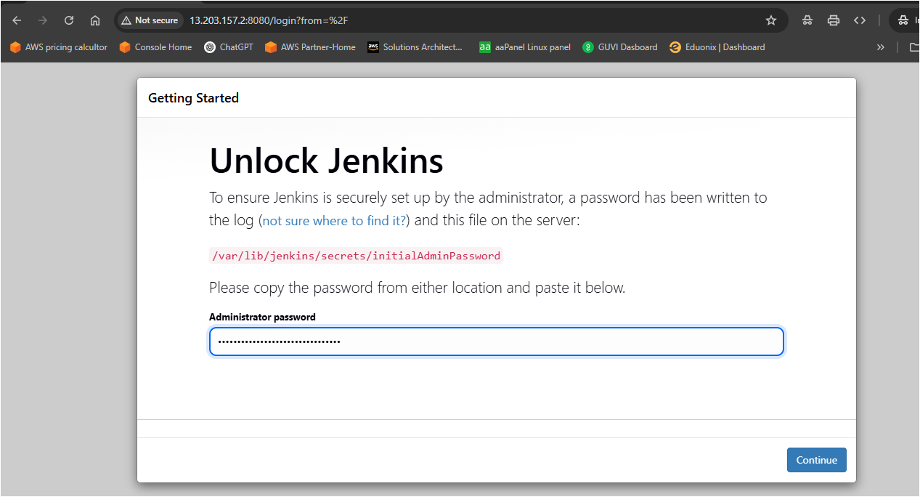
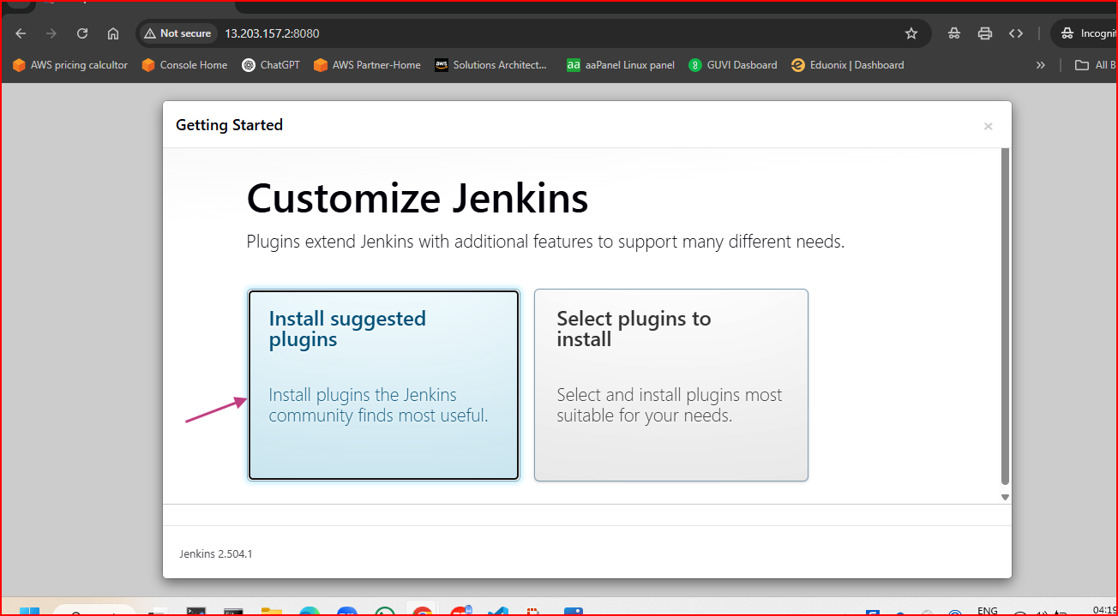
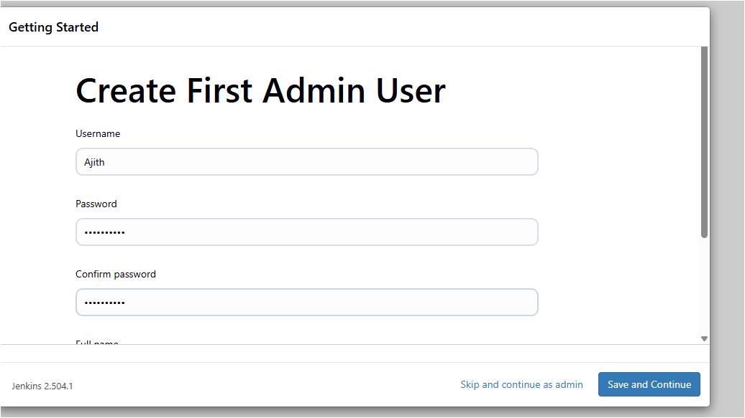
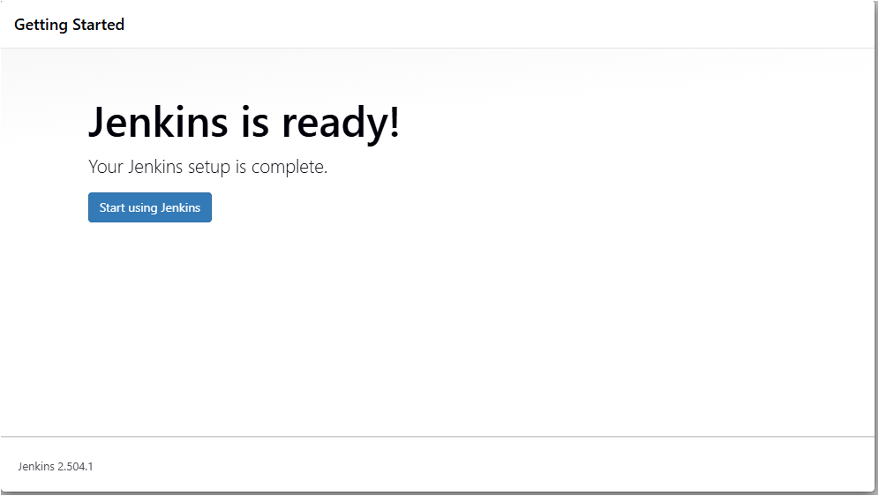
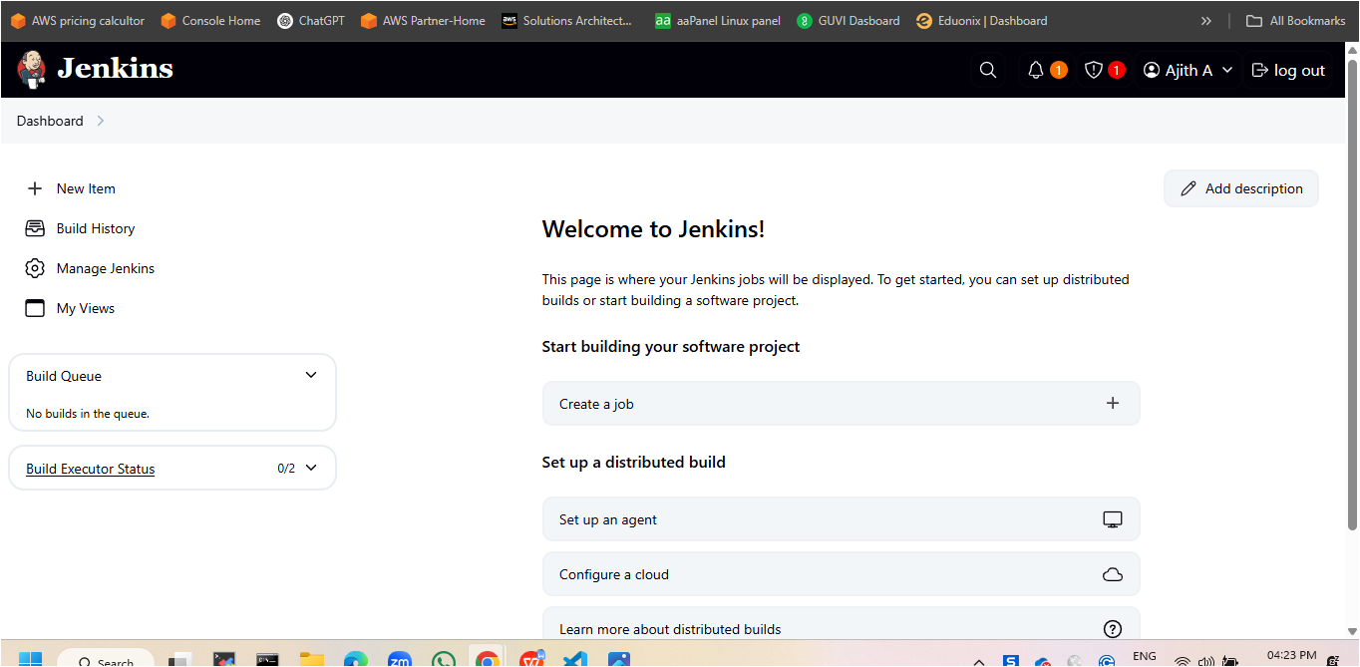
Jenkins Configuration
✅ Install Required Plugins:
Git
Docker
Docker Pipeline
GitHub Integration
Blue Ocean (optional)
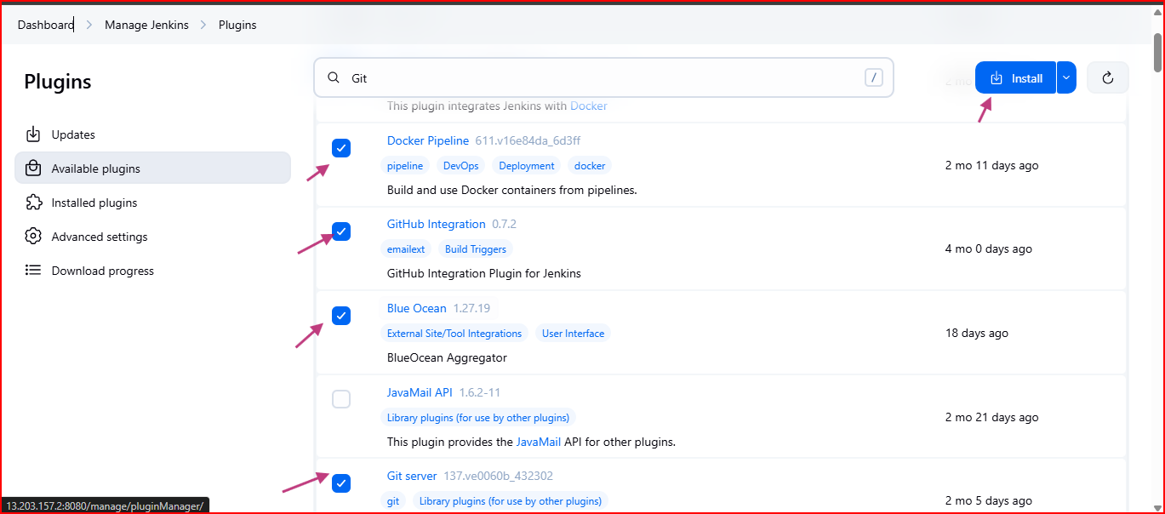
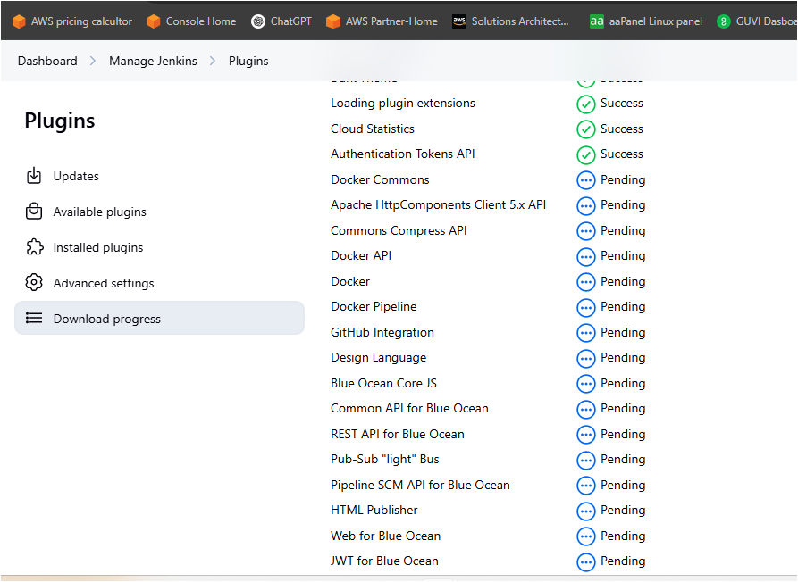
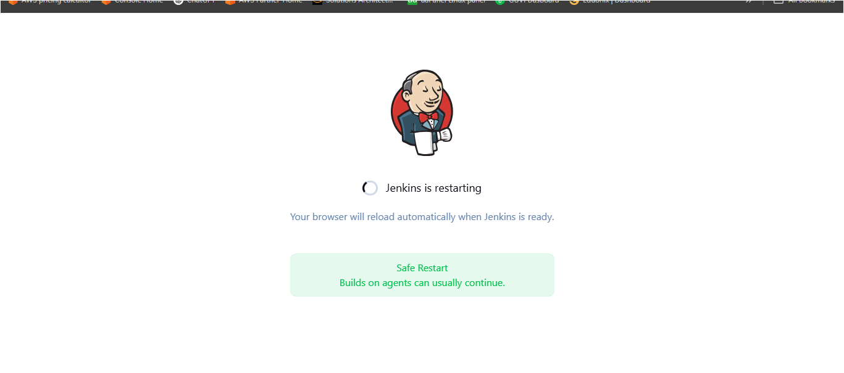
Install Docker
sudo apt update
sudo apt install -y docker.io
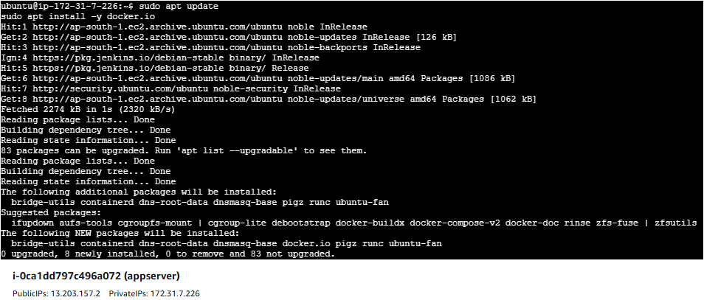

Then enable and start Docker:
sudo systemctl enable docker
sudo systemctl start docker
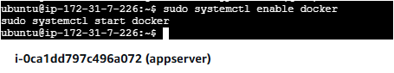

Create the docker group
sudo groupadd docker
Add jenkins user to docker group
sudo usermod -aG docker jenkins
Restart Jenkins service
sudo systemctl restart jenkins
Test if it works
docker version
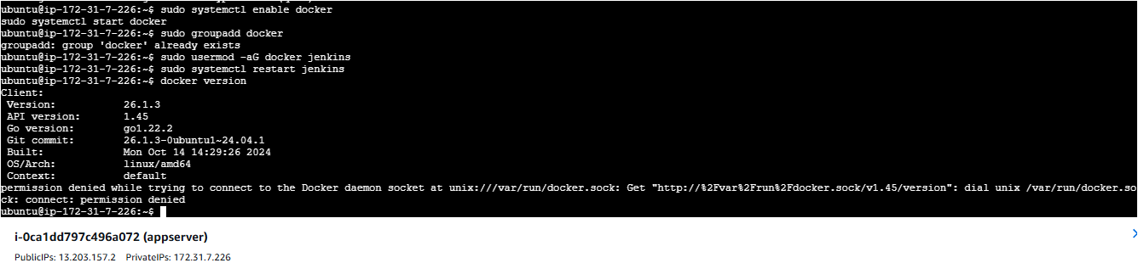

Create Credentials:
Go to: Manage Jenkins > Credentials > (Global)
Add DockerHub credentials (ID: dockerhub-creds)
Step-by-Step: Add Credentials in Jenkins
1. Open Jenkins Credentials Section
Navigate to your Jenkins dashboard.
Go to:
Manage Jenkins → Credentials → (global) → Add Credentials
A. Add DockerHub Credentials (Username & Password)
Kind: Username with password

Scope: Global
Username: Your DockerHub username
Password: Your DockerHub password or access token

ID: dockerhub-creds
Description: DockerHub login credentials
👉 Click OK to save.
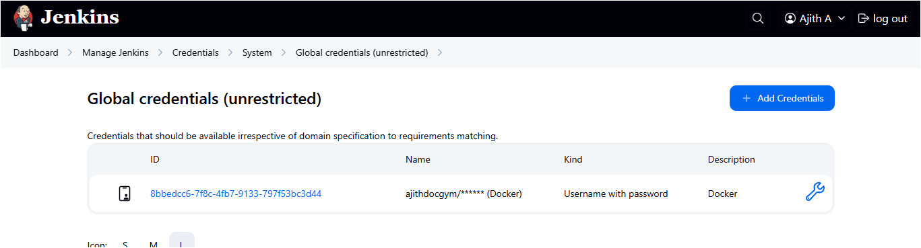

Pipeline Project
Create "New Item" > Pipeline
Use the Jenkinsfile in your repo
Add webhook for GitHub triggers
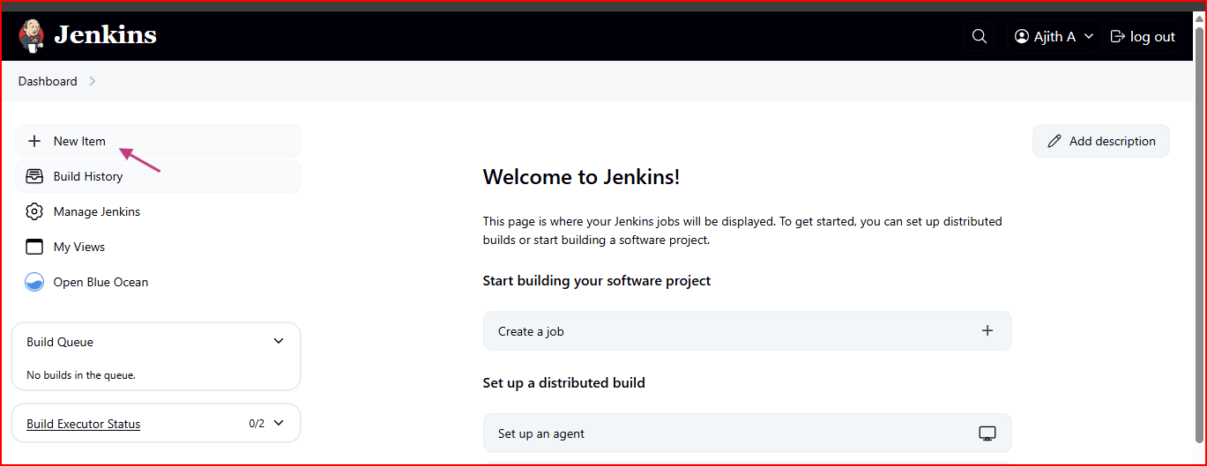
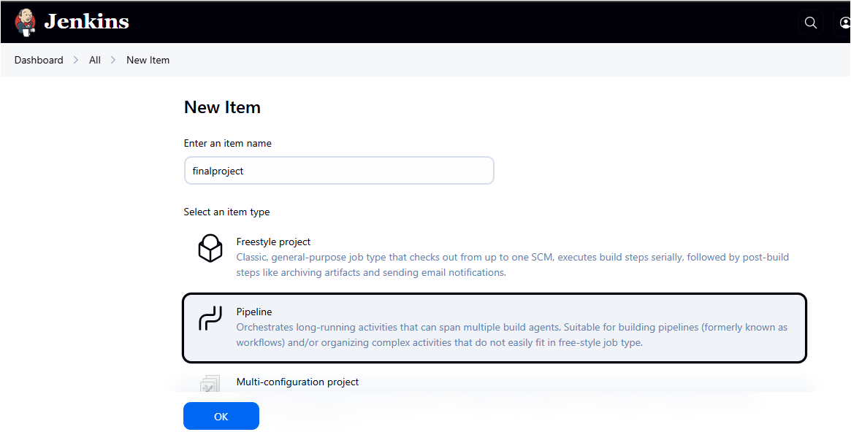
Webhook link
